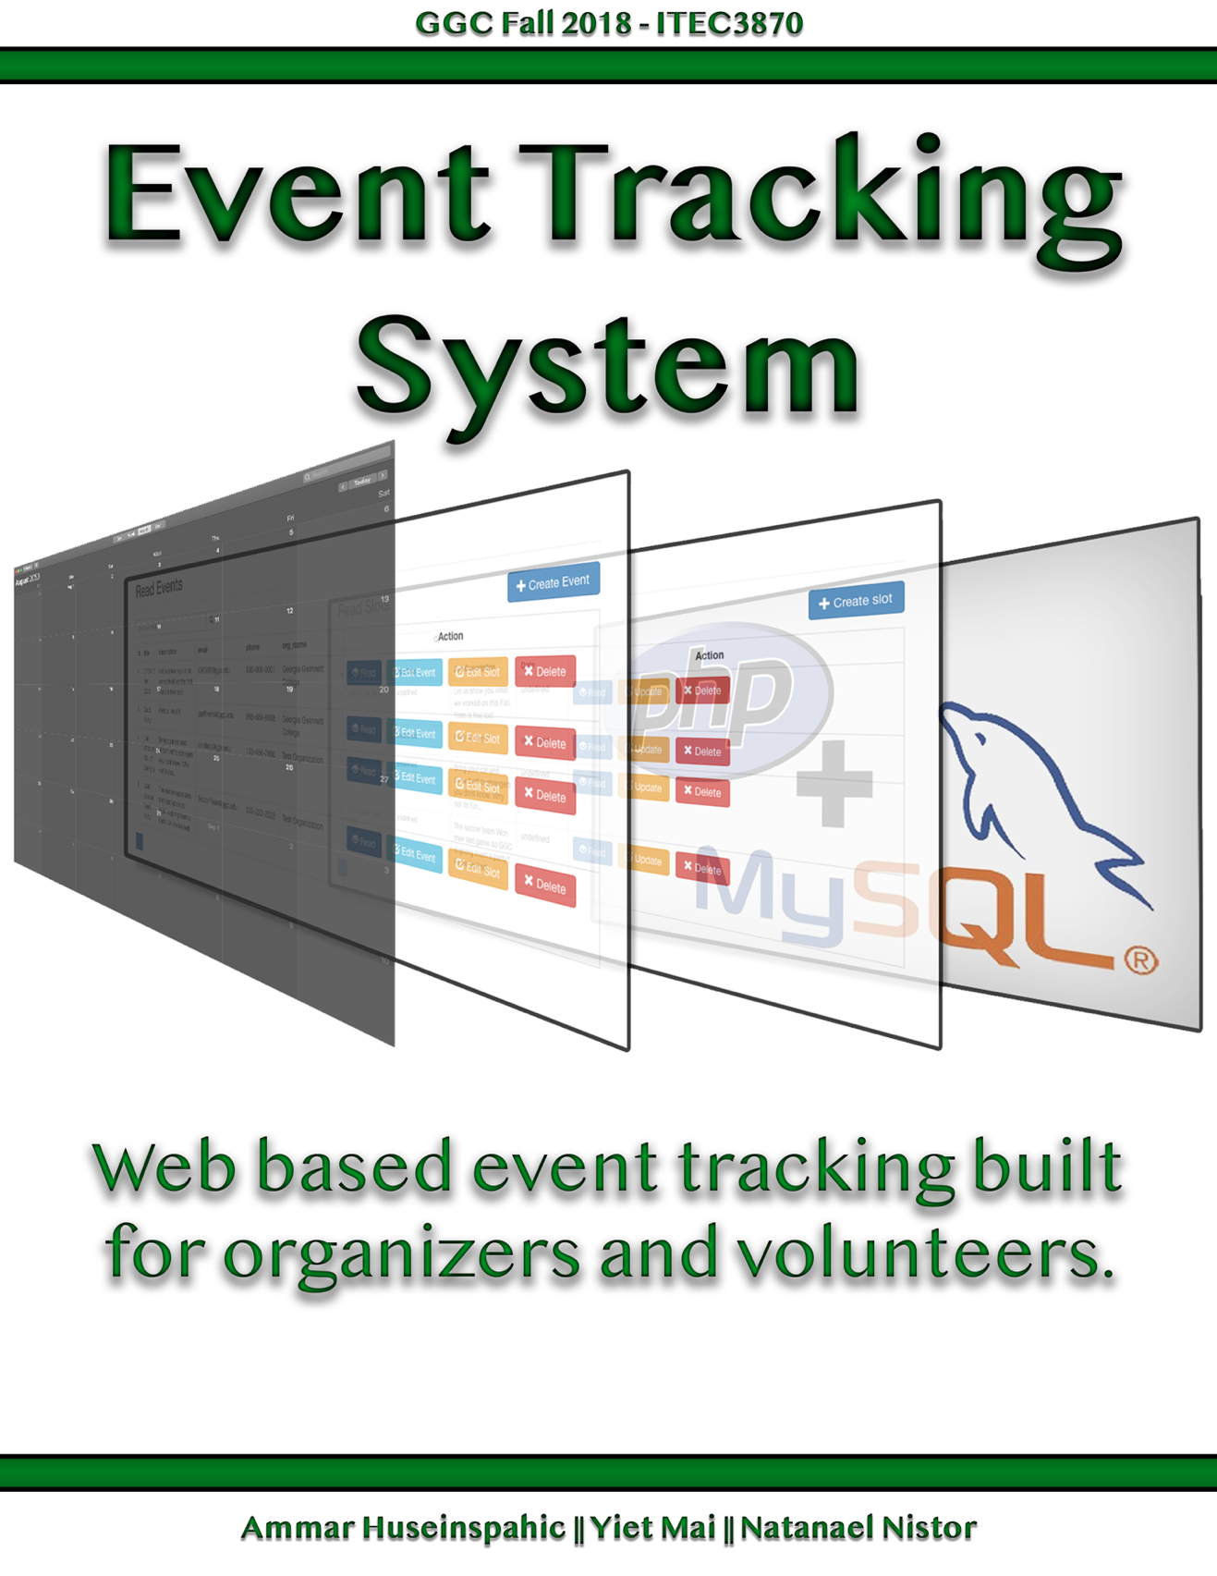

TABLE OF CONTENTS

Installation 3

WAMP/XAMPP

Version Numbers

Features 4

Implemented Features

Slots

Events

Organizations

Missing Features 4-5

Known Issues 5

Functionality 5

Backend

Slot

Event

Organization 6

User

Frontend

Event Read 6-7

Event Create 8

Event Update 9

Event Delete 10

Testing Coverage 11

Program #

Read Test 12-13

Create/Delete Test 14-15

Team Members 16

Team Introduction #

Ammar Huseinspahic 17

Yiet Mai 18

Natanael V Nistor 19

Survey 20

Licensing Agreement 21

signatures 22

# Installation

WAMPServer and XAMPP are windows web development environments. They allow local hosting of web applications with apache, PHP and the MySQL database. They also come with phpMyAdmin and sqlitemanager for database management.

Installing WAMP

Download Link: <http://www.wampserver.com/dl.php>

1. Double click on the downloaded file and just follow the instructions. Everything is automatic. The WAMPServer package is delivered with the latest releases of apache, MySQL and php.
2. Once WAMPServer is installed, you can manually add additional components for apache, php or MySQL (only vc9, vc10 and vc11 compiled) versions.

Using WAMP

1. Run WAMPServer
2. The “www” directory will be automatically created (usually c:\wamp\www)
3. Create a subdirectory in “www” and put your project files inside.
4. Click on the “localhost” link in the WAMPServer menu or open your internet browser and go to the url : <http://localhost>

Installing XAMPP

Download Link: https://www.apachefriends.org/index.html

1. Double click on the downloaded file and just follow the instructions. You have the choice of installing various components such as MySQL, phpMyAdmin, Apache, and more from within the installer (Leave to default for this project).

Using XAMPP

1. The XAMPP Control Panel includes three main sections. In Modules, you will find all the services available. You can run each service by clicking the Start button.
2. The default settings should work for most people using XAMPP to create a testing environment to run a website for personal use or a client. However, depending on your setup configuration, you may need to change the TCP/IP port number for the Apache server, the database upload size, or set the password for phpMyAdmin. Click the Config button for those settings.

# Version Numbers

The project was created on these version numbers. If you have errors in the future, try to roll back to one of these versions.

1. Apache – 2.4.27
2. PHP – 7.1.9
3. phpMyAdmin – 4.7.4
4. MySQL – 5.7.19

# Features

Implemented Features

1. Backend
   1. Slots
      1. Create, Read, Update, Delete
      2. Paging
      3. Search Slot by ID
      4. Search Slot by Event
   2. Events
      1. Create, Read, Update, Delete
      2. Assign event to organization
      3. Assign slots to event
      4. Return slots belonging to event
      5. Search Event by ID
   3. Organizations
      1. Create, Read, Update, Delete
      2. Register user to organization
      3. Return Events by Organization
   4. Users
      1. Create, Read, Update, Delete
      2. Log in with token validation
      3. Token expiration
2. Frontend
   1. Example Documents
      1. Reading items using API
      2. Using paging to read Slots from API
      3. Deleting a Slot using API
      4. Creating a Slot using API
   2. AJAX/JQuery live table
      1. Creating Events
      2. Viewing Events
      3. Updating Events
      4. Deleting Events
   3. Login Page for users
      1. Validates user info
      2. Assigns token to user
      3. Token checked

Missing Features

1. Backend
   1. Token Validation for Creating, Updating, and Deleting
      1. Slots
      2. Events
      3. Organizations
   2. Assigning pictures to events/Allowing upload
2. Frontend
   1. Viewing all data in a single page
   2. Sign Up Page
   3. Organizer Monitoring for volunteers
   4. Creation page for events
   5. User profile page

# Known Issues

Back End

1. Items are created without checking for token validation
2. Items are deleted without checking for token validation
3. Testing is has not been done on all functions
4. Searching descriptions/titles is broken for Slots, Events, and organizations

Front End

1. No front-end display for all features

# Functionality

Backend

1. Slots
   1. Read - /ProjectFolder/api/objects/slots/read/
      1. By default will show you all slots in database
      2. Add ‘?id = #’ to the url to get specific Slot with that ID
      3. Add ‘?page=#’ to the url for 10(default) slots on the # page
      4. Add ‘?page=#&count=% ’ to the url for % slots on the# page
   2. Create - /ProjectFolder/api/objects/slots/create/
      1. Post to page with variables (event_id, title, description, date, starttime, endtime, min, max)
   3. Update - /ProjectFolder/api/objects/slots/update/
      1. Post to page with variables (id, title, description, date, starttime, endtime, min, max)
   4. Delete - /ProjectFolder/api/objects/slots/delete/
      1. Post to page with ‘id’
2. Events
   1. Read - /ProjectFolder/api/objects/events/read/
      1. By default will show you all events in database
      2. Add ‘?id = #’ to the url to get specific Slot with that ID
   2. Create - /ProjectFolder/api/objects/events/create/
      1. Post to page with variables (title, description, email, phone, public)
   3. Update - /ProjectFolder/api/objects/events/update/
      1. Post to page with variables (id, title, description, email, phone, public)
   4. Delete - /ProjectFolder/api/objects/events/delete/
      1. Post to page with ‘id’
3. Organizations
   1. Read - /ProjectFolder/api/objects/events/read/
      1. By default will show you all slots in database
      2. Add ‘?id = #’ to the url to get specific Slot with that ID
   2. Create - /ProjectFolder/api/objects/events/create/
      1. Post to page with variables (title, description, email, phone, public)
   3. Update - /ProjectFolder/api/objects/events/update/
      1. Post to page with variables (id, title, description, email, phone, public)
   4. Delete - /ProjectFolder/api/objects/events/delete/
      1. Post to page with ‘id’

Frontend

**Viewing Events**

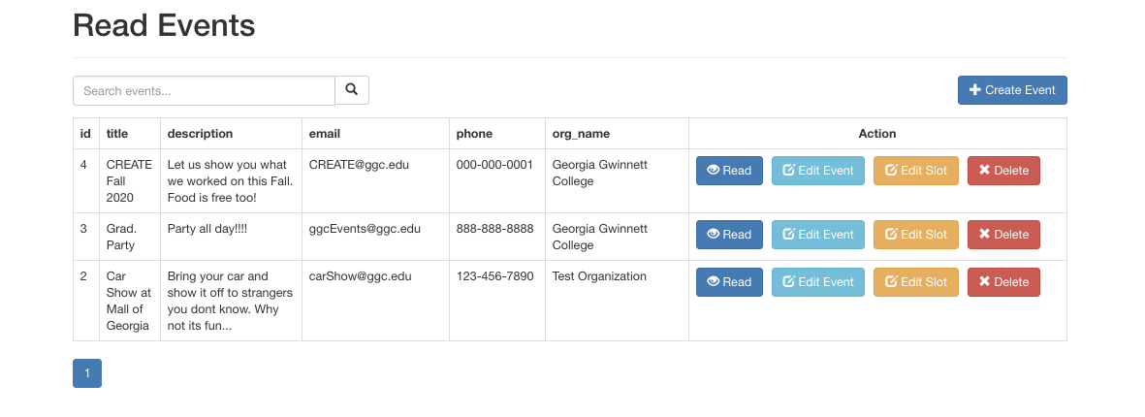

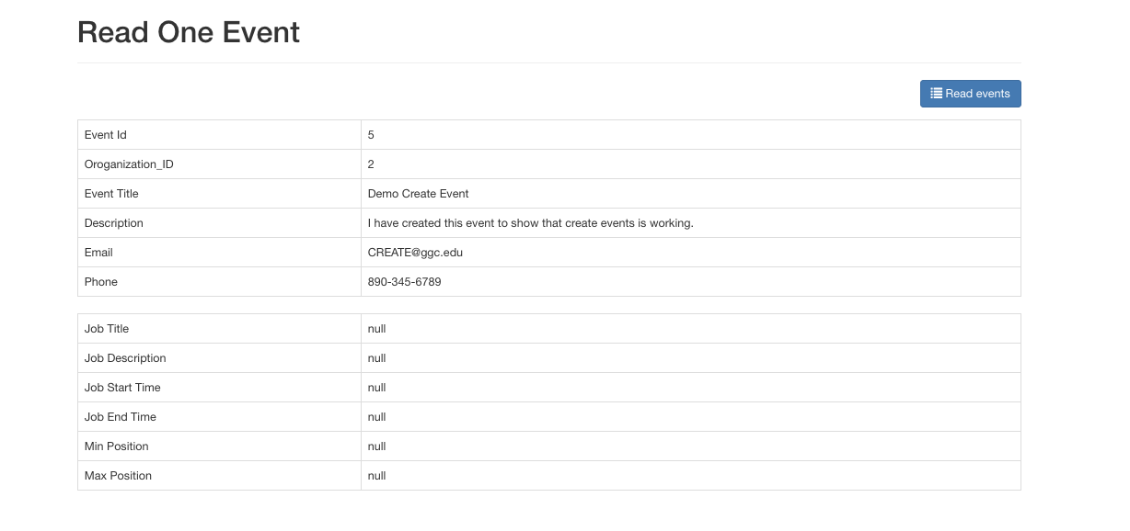

**Viewing Events (Code)**

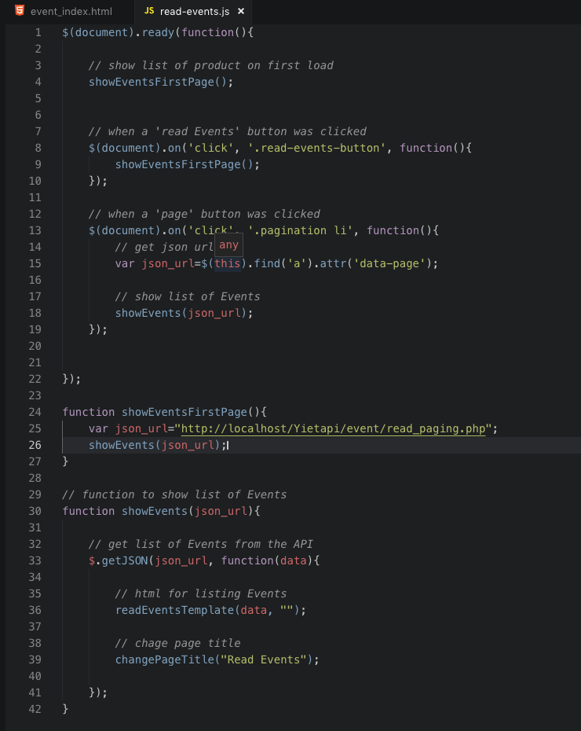

**Create Events**

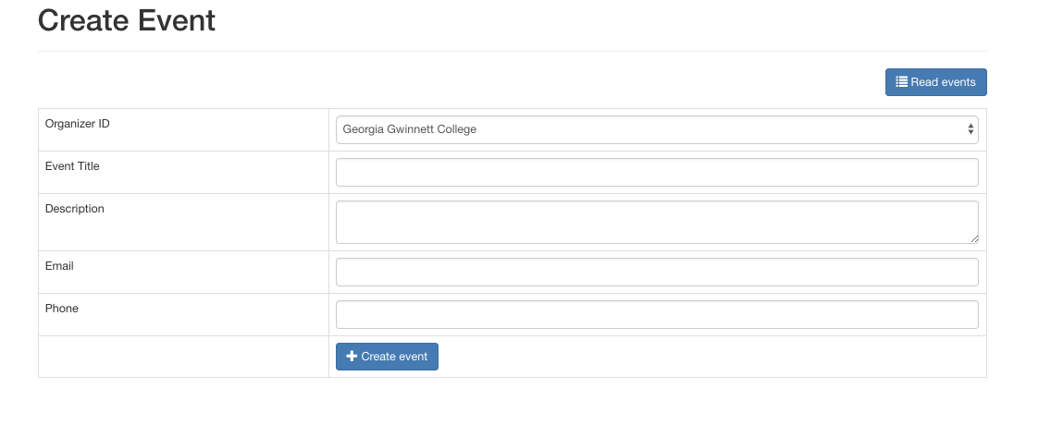

**Create Events (Code)**

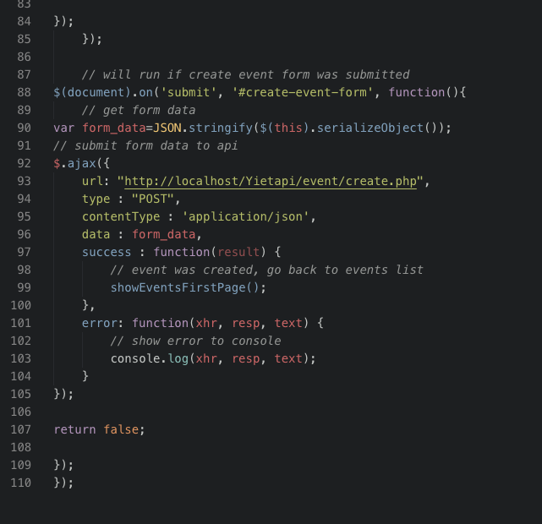

**Update Events**

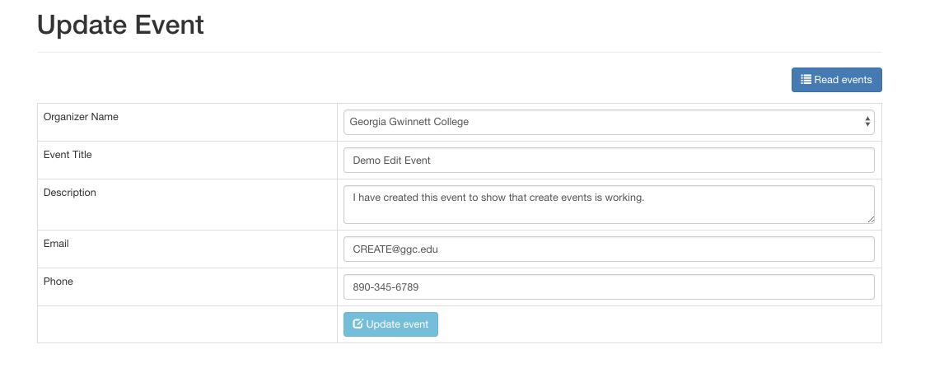

**Update Events (Code) *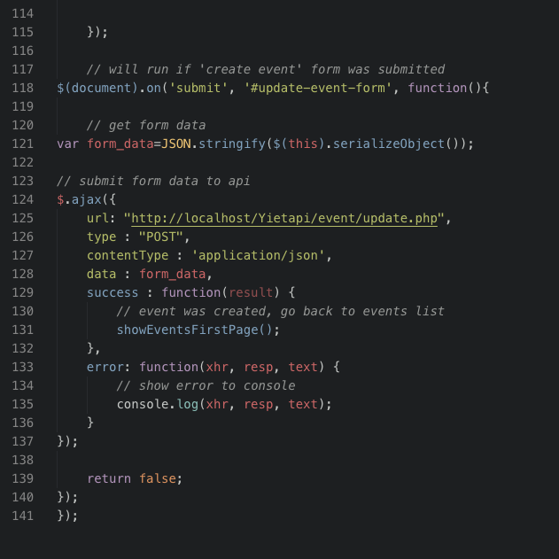***

**Delete Events**

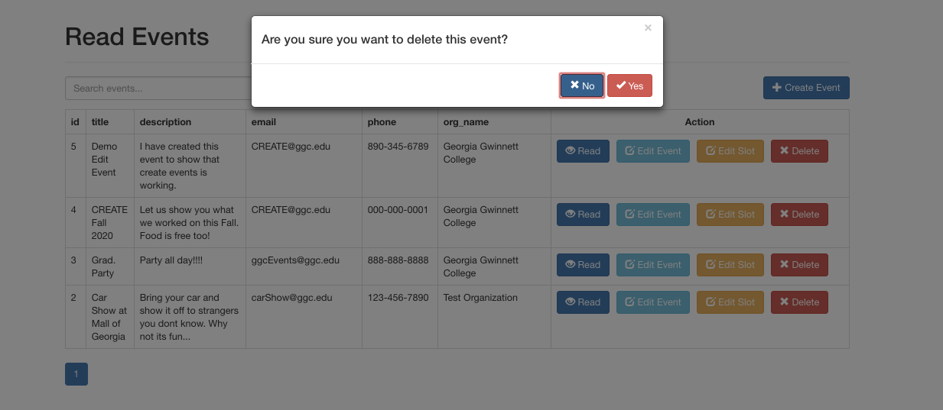

**Delete Events (Code)**

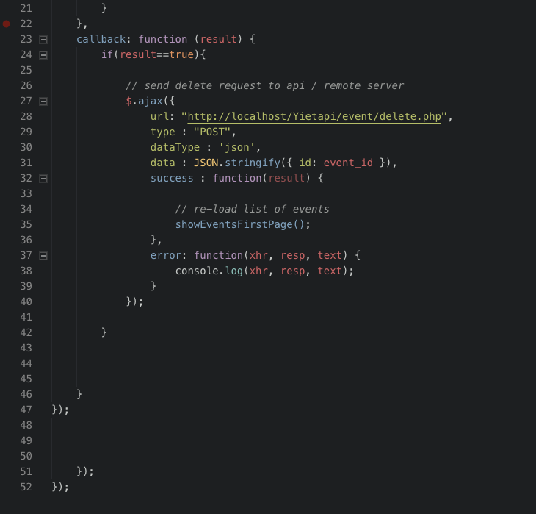

# Testing Coverage

Program

Codeception was used for testing on the web application. Codeception is a multi-featured testing framework for PHP. It can handle unit, functional, and acceptance testing of web applications and it's powered by the already very popular PHPUnit testing framework.

Acceptance testing allows us to test our applications using the normal website viewing process of visit a webpage, fill in a form, and submit the form to see the desired result. The difference is with Codeception, we don't have to waste time going to the browser each time we want to test a new feature out, instead we can just run our acceptance tests to see if they pass or not.

<https://code.tutsplus.com/tutorials/acceptance-testing-with-codeception--net-36337>

The link above provides a thorough tutorial for installing and using Codeception.

**

**Read Test**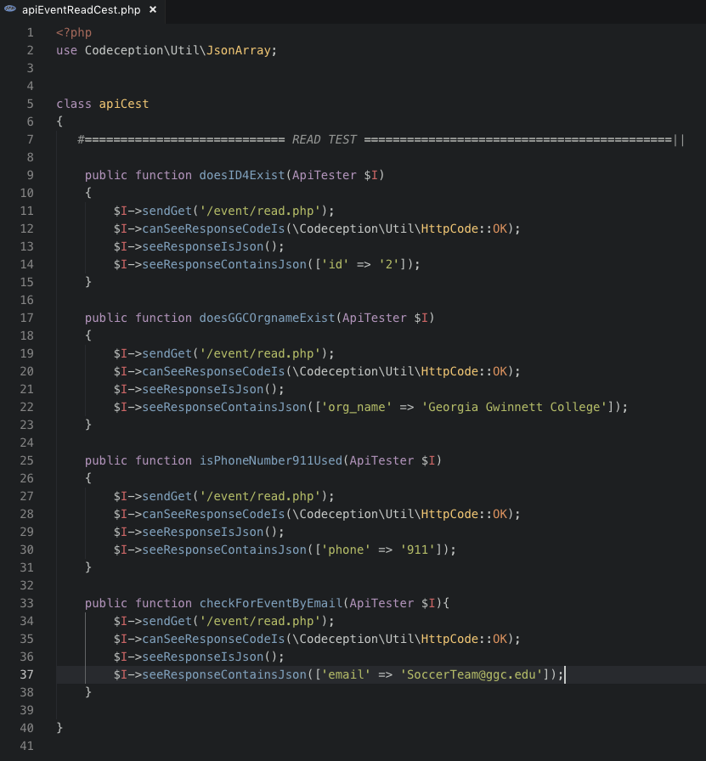

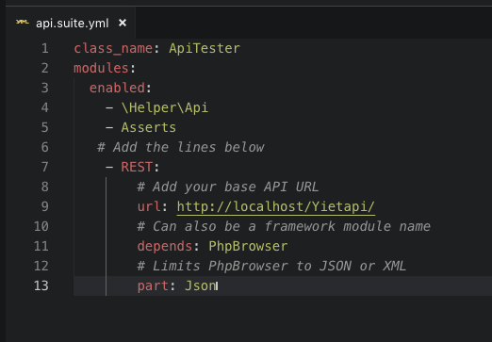

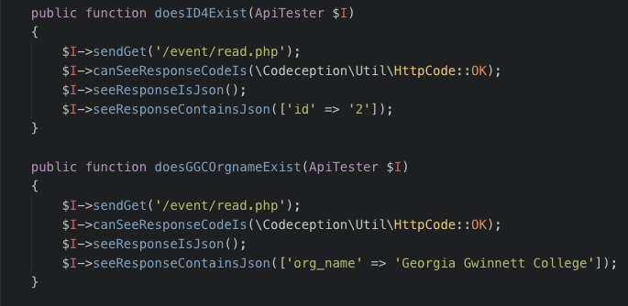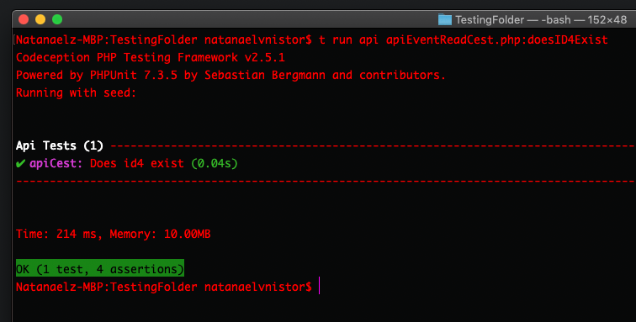

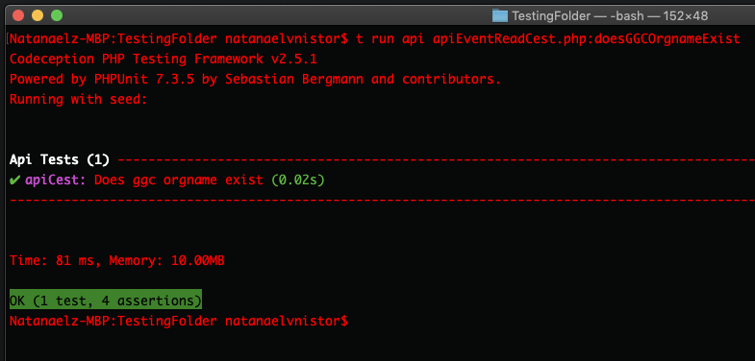

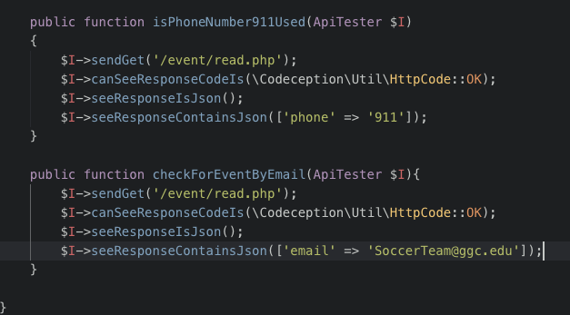

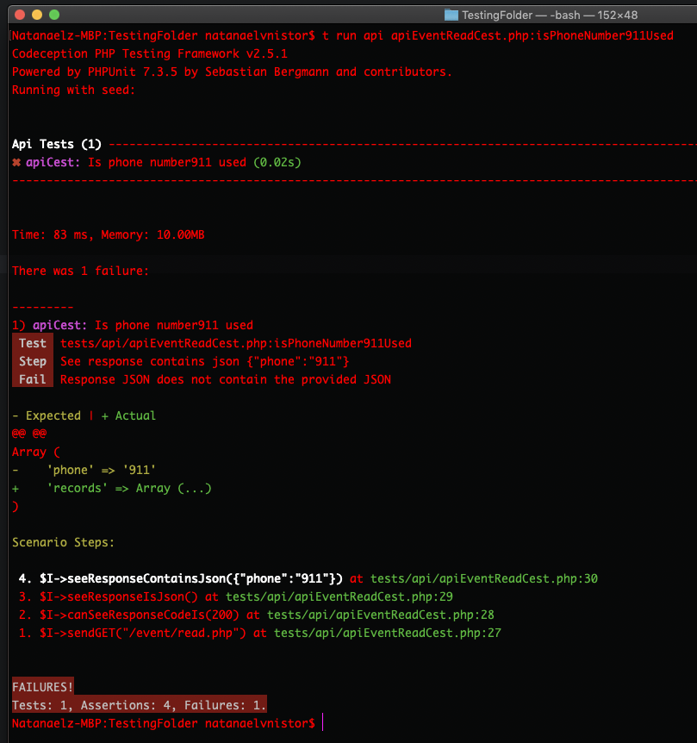

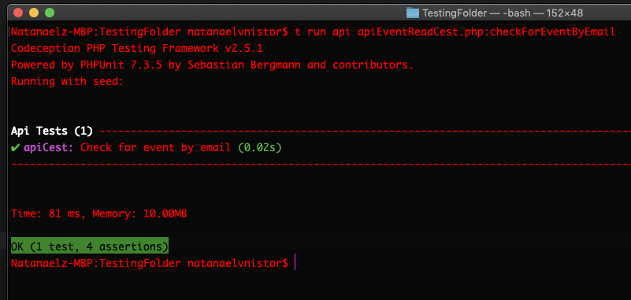

**Create/Delete Test**

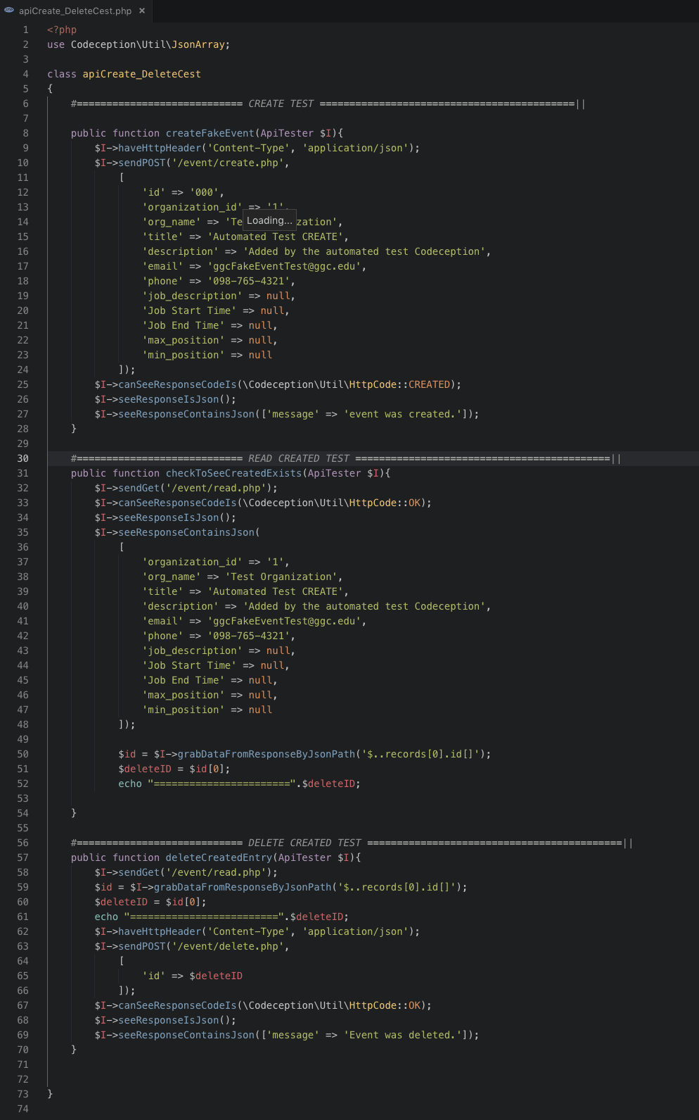

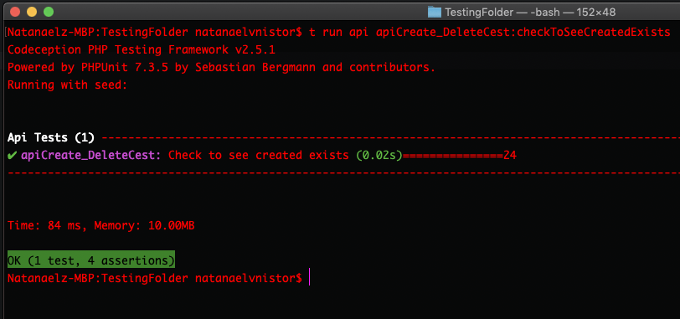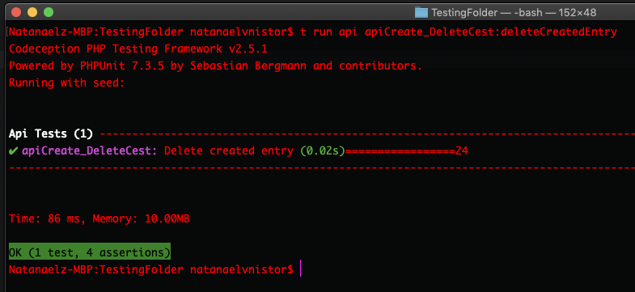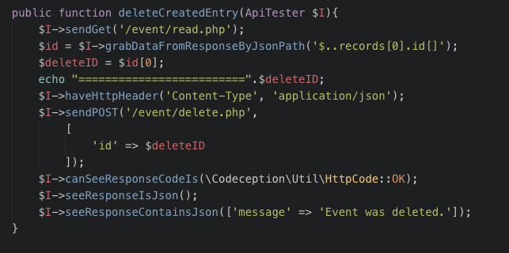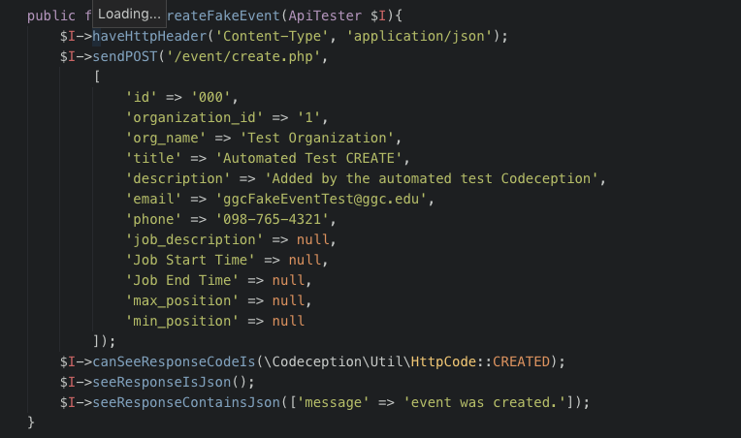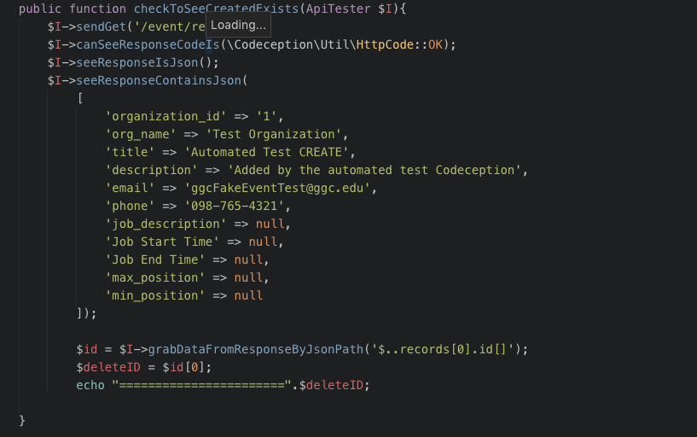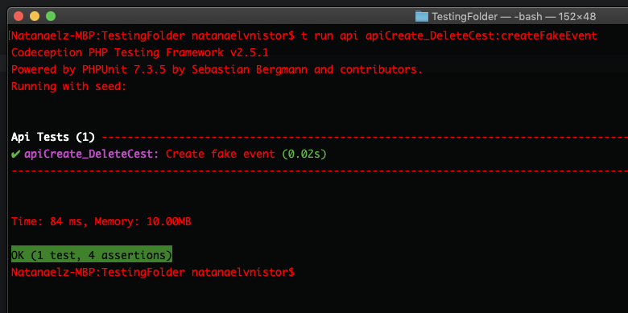

# Team Members

Project Introduction

Student Michael Holtmann (mikedh87@gmail.com, (404) 431-8272) wants a website for volunteer and event tracking. User stories: I would like a web based software that will help with the origination of volunteers across many events. I need the ability to place, on a calendar, an event and break it into time slots and number of volunteers needed. I my volunteers to have the ability to register for a specific time slot for a specific day and specific event. I need the system to track who signed up to help for a specific time slot for a specific day and specific event.

Rules:

1. Teams must be at least 3 and up to 4 people. Exception; to be a 5-person team, you really need to justify why you need so many people. That doesn't mean "oh this project is so big!", you have to clearly separate the work into different members.
2. You're free to come up with ideas, but you need to make sure your client accepts your plan. You can always bring more external clients to the class.
3. Each person must have one or multiple of the roles below.

Team Roles

1. Code architecture/lead programmer: framework, components, coding style. Doesn't mean the only programmer! Everyone must program, lead programmer decides on the overall design and coding standards.
2. UI/UX design: User Interface and User experience. Make mock UI designs and user-friendly navigation.
3. Data modeler: Database, data files, server-client structure, data structures.
4. Team manager: Sprint planning, and time accounting for the team.
5. Client liaison: Communications, demos, and negotiations with client, what was done and planned to handle client's requirements (role can be combined with manager)
6. Documentation lead: Setup documentation conventions for code and project, then delegate work onto teammates. Manage presentations, reports, and licensing documentation. Everyone must add documentation!
7. Testing lead: Setup testing framework and conventions. Use continuous integration to test at each commit/push. Everyone must do their own testing!



Ammar Huseinspahic

***Code Architecture / Lead Programmer & Testing Lead***

Concentration: System Security

Year: Graduating Senior

Languages: PHP, CSS, JavaScript, C#, Java

Programs: Unity, PhotoShop, WAMP

Past Software Projects:

* Software Dev 1: 2d web game featuring dynamic game world, sounds, and multiplayer
* Info Project: Study Room reservation system with online tracking of room availability
* Website for local business made with BootStrap
* Lots of personal side projects



Yiet Mai

***Data Modeler & UI/UX Design***

Year: May, 2019

Skills (computer languages, platforms, etc)

- Java

- Javascript

- PHP

- HTML & CSS

- SQL & mySQL

Interests (keep it relevant)

- Designing and building web

- Software Development

- Game development

Expertise in software development tools (IDEs, version control, build tools, etc)

- IDE's: Eclipse

- Sublime

- Netbean

- Atom

Past software projects (briefly explain the scope and your role)

- Software Development I Text Base Adventure Game.

- Projects from Web Dev.

- Projects from Digital Media

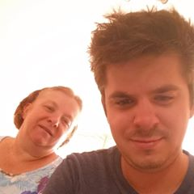

Natanael V. Nistor

***Team Manager, Client Liaison, & Documentation Lead***

Concentration: Software Dev

Year: Senior

Languages:

* Java
* JavaScript
* jQuery
* SQL
* Html/CSS
* React
* PHP

IDE / Editors: Eclipse, Atom.io, VS Code, IntelliJ, Note Pad ++, Android Studio, Unity

Interests:

- Coding …

- AI

- Web Dev

- Games Dev

- Drones

Projects:

- Text Based Game (Java)

- Small Web Technology websites projects

- Other Class Homework and Assignments

**Survey**

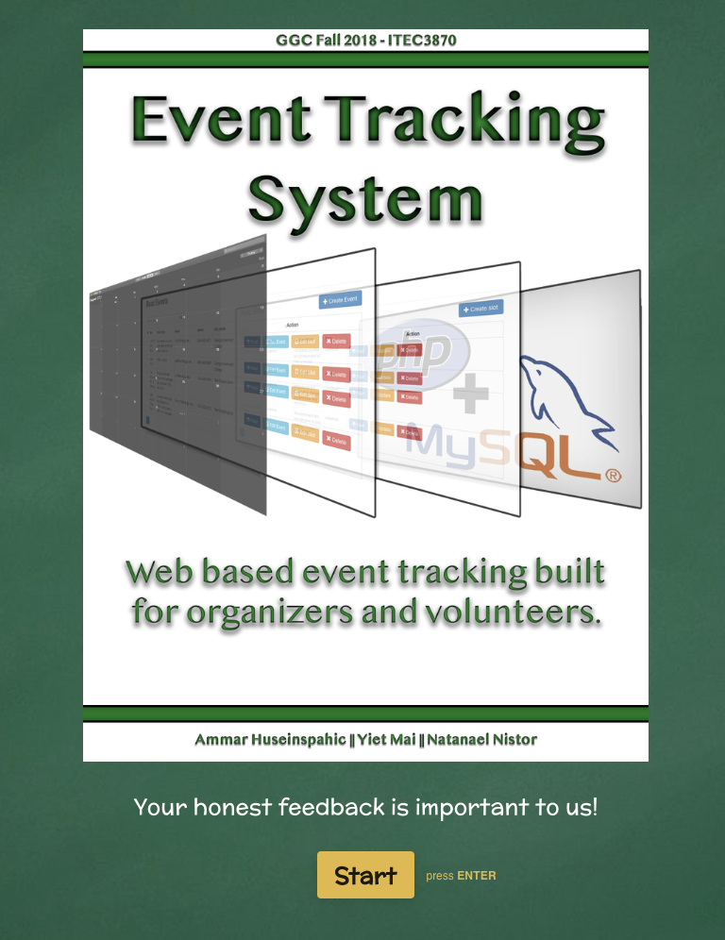

<https://evtsys2018.typeform.com/to/XtUneI>

EVENT TRACKER

INTELLECTUAL PROPERTY AND LICENSING AGREEMENT

[Creative Commons Attribution Non-Commercial (CC-BY-NC)]

This Intellectual Property Contribution and Assignment Agreement (the “Agreement”) is made as of 22 November

2018 by and between the members of Event Tracker (the “Company”), Michael Holtmann (the “Client”), and Dr. Cengiz Gunay (the “Sponsor”).

**1. Intellectual Property Assignment**

BOTH PARTIES HAVE AGREED THAT THE MEMBERS OF COMPANY WILL EACH RECEIVE TEN PERCENT OF INTELLECTUAL CLAIM, THE CLIENT WOULD BE ASSIGNED SIXTY-FIVE PERCENT OF INTELLECTUAL CLAIM, AND THE SPONSOR WOULD BE ASSIGNED FIVE PERCENT OF INTELLECTUAL CLAIM. INTELLECTUAL CLAIM INCLUDES ENTIRE RIGHTS, TITLE AND INTEREST IN AND TO ANY AND ALL OF THE PROPERTIES THAT EXIST AS OF THE DATE HEREOF.

**2. Licensing Agreement**

THE WORK (EVENT TRACKER) IS PROVIDED UNDER THE TERMS OF THIS CREATIVE COMMONS PUBLIC

LICENSE ("CCPL" OR "LICENSE"). THE WORK IS PROTECTED BY COPYRIGHT AND/OR OTHER APPLICABLE LAW. ANY USE OF THE WORK OTHER THAN AS AUTHORIZED UNDER THIS LICENSE OR COPYRIGHT LAW IS PROHIBITED. BY EXERCISING ANY RIGHTS TO THE WORK PROVIDED HERE, YOU ACCEPT AND AGREE TO BE BOUND BY THE TERMS OF THIS LICENSE. TO THE EXTENT THIS LICENSE MAY BE CONSIDERED TO BE A CONTRACT, THE LICENSOR GRANTS YOU THE RIGHTS CONTAINED HERE IN CONSIDERATION OF YOUR ACCEPTANCE OF SUCH TERMS AND CONDITIONS.

**3. Representations, Warranties and Disclaimer**

UNLESS OTHERWISE MUTUALLY AGREED TO BY THE PARTIES IN WRITING, LICENSOR OFFERS THE WORK

AS-IS AND MAKES NO REPRESENTATIONS OR WARRANTIES OF ANY KIND CONCERNING THE WORK, EXPRESS, IMPLIED, STATUTORY OR OTHERWISE, INCLUDING, WITHOUT LIMITATION, WARRANTIES OF TITLE, MERCHANTIBILITY, FITNESS FOR A PARTICULAR PURPOSE, NONINFRINGEMENT, OR THE ABSENCE OF LATENT OR OTHER DEFECTS, ACCURACY, OR THE PRESENCE OF ABSENCE OF ERRORS, WHETHER OR NOT DISCOVERABLE. SOME JURISDICTIONS DO NOT ALLOW THE EXCLUSION OF IMPLIED WARRANTIES, SO SUCH EXCLUSION MAY NOT APPLY TO YOU.

**4. Limitation on Liability**

EXCEPT TO THE EXTENT REQUIRED BY APPLICABLE LAW, IN NO EVENT WILL LICENSOR BE LIABLE TO YOU

ON ANY LEGAL THEORY FOR ANY SPECIAL, INCIDENTAL, CONSEQUENTIAL, PUNITIVE OR EXEMPLARY DAMAGES ARISING OUT OF THIS LICENSE OR THE USE OF THE WORK, EVEN IF LICENSOR HAS BEEN ADVISED OF THE POSSIBILITY OF SUCH DAMAGES.

**5. Termination**

THIS LICENSE AND THE RIGHTS GRANTED HEREUNDER WILL TERMINATE AUTOMATICALLY UPON ANY

BREACH BY YOU OF THE TERMS OF THIS LICENSE. INDIVIDUALS OR ENTITIES WHO HAVE RECEIVED ADAPTATIONS OR COLLECTIONS FROM YOU UNDER THIS LICENSE, HOWEVER, WILL NOT HAVE THEIR LICENSES TERMINATED PROVIDED SUCH INDIVIDUALS OR ENTITIES REMAIN IN FULL COMPLIANCE WITH THOSE LICENSES.

